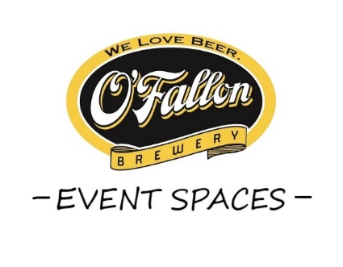

Check out our Event Spaces!
Impress your guests and host your next Event at a Brewery!
Great options for corporate happy hours, celebrations, presentations, birthdays,
weddings, receptions, rehearsals and more! Private tours available!
Contact us for more information or to see the spaces in person!
info@ofallonbrewery.com | (636-474-2337 ext. 104)

